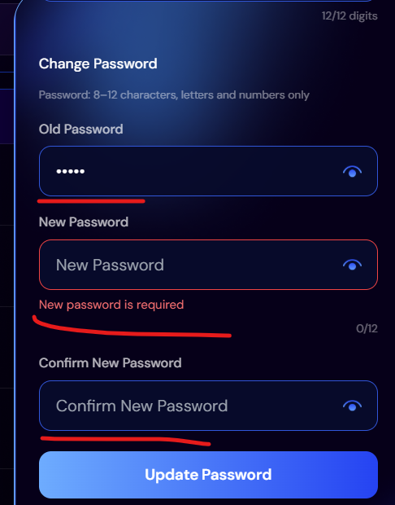
Error message is shown 1 by 1. Old password in incorrect and both password and new password fields are empty but is shows error only on new password field

